IVC   
Unit Test Report  
 **Driver to EM Torque Domain Conversion**

Contents

1. Driver to EM Torque Domain Conversion Functionality 3

2. Test Model Overview 3

3. Protocols & Requirements 4

4. Results 5

1. Driver to EM Torque Domain Conversion Functionality

The *Driver to EM Torque Domain Conversion* block carries the functionality of converting the requested torque from the Driver domain into the Electric Machine (EM) domain.

The torque in the Driver domain reflects the driver’s intention on pressing or not the accelerator pedal (requesting either propulsion or braking), while the torque in the Electric Machine domain is related with its rotational direction. Therefore, a positive Driver domain torque will be positive if, for instance, the driver is pressing the accelerator pedal at full throttle and negative if the driver is not pressing it. On the other hand, the Electric Machine domain torque is positive when the torque is in the rotational forward direction and negative when the torque is in the rotational backwards direction. In Table 1, the 8 possible different situations regarding the torque signs in the different domains are shown, where $M_{D}$ is the driver domain torque, $v$ the EM speed and $M_{E}$ the EM domain torque. It can be seen that, for example in Drive Mode, a negative torque in the driver domain (not pressing the accelerator pedal) when going backwards (in an uphill slope) is actually a positive torque in the EM domain due to the regenerative braking in the rotational forward direction.

|  |  |  |  |  |  |  |  |  |
| --- | --- | --- | --- | --- | --- | --- | --- | --- |
| **Driveline State** | Drive Mode | | | | Reverse Mode | | | |
| **Driver domain torque** | $$M_{D}^{+}$$ | | $$M_{D}^{-}$$ | | $$M_{D}^{+}$$ | | $$M_{D}^{-}$$ | |
| **EM speed** | $$v^{+}$$ | $$v^{-}$$ | $$v^{+}$$ | $$v^{-}$$ | $$v^{+}$$ | $$v^{-}$$ | $$v^{+}$$ | $$v^{-}$$ |
| **EM domain torque** | $$M_{E}^{+}$$ | $$M_{E}^{+}$$ | $$M_{E}^{-}$$ | $$M_{E}^{+}$$ | $$M_{E}^{-}$$ | $$M_{E}^{-}$$ | $$M_{E}^{-}$$ | $$M_{E}^{+}$$ |

Table 1: Driver to EM Torque Domain Conversion signs .

1. Test Model Overview

The test model used for the unit test of Driver to EM Torque Domain Conversion block can be seen in Figure 1. The test variables are: *Electric Machine (EM) Speed, Driveline State* and *Driver Domain Torque.*

The Simulink model is designed using mainly comparison and *IfThenElse* blocks in order to cover each particular case stated in Table 1. Simpler models that also accomplish the desired task could be implemented, however they would not be as intuitive as the one shown in Figure 1.

The first step is to test if the Driveline State is either in *Park* or *Neutral* and if so the output torque will be zero. If not, then it is checked if the Driveline State is *Drive*. When in *Drive* mode, the chain continues down to the next *IfThenElse* block and when not, then the Driveline State is *Reverse*, meaning that the chain will continue on the *IfThenElse* blocks on the right side. In both cases, comparisons are made in order to obtain the correct output EM domain torque, taking into account the sign of both the Driver domain torque and the EM speed.

No bus objects or buses have been used in this test model. Instead, all input signals and parameters have been simulated using constants and, thus, the model does not account for bus compatibility testing.

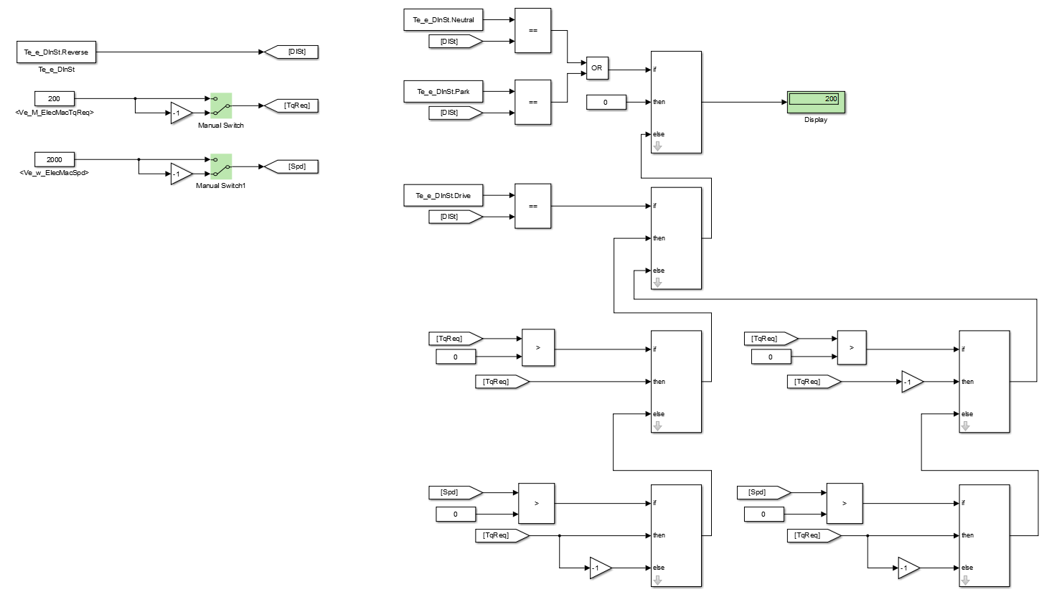

Figure 1: Test model used for testing the Driver to EM Torque Domain Conversion block.

1. Protocols & Requirements

With the *Driver Domain Torque* and *EM Speed* absolute value set to 200 and 2000 respectively, the test protocol went as follows:

* *Driveline State* (**Neutral**), *Driver Domain Torque* (**positive/negative**), *EM Speed* (**positive/negative**).

Expectation: output torque 0

* *Driveline State* (**Park**), *Driver Domain Torque* (**positive/negative**), *EM Speed* (**positive/negative**).

Expectation: output torque 0

* *Driveline State* (**Drive**), *Driver Domain Torque* (**positive**), *EM Speed* (**positive**).

Expectation: output torque positive

* *Driveline State* (**Drive**), *Driver Domain Torque* (**positive**), *EM Speed* (**negative**).

Expectation: output torque positive

* *Driveline State* (**Drive**), *Driver Domain Torque* (**negative**), *EM Speed* (**positive**).

Expectation: output torque negative

* *Driveline State* (**Drive**), *Driver Domain Torque* (**negative**), *EM Speed* (**negative**).

Expectation: output torque positive

* *Driveline State* (**Reverse**), *Driver Domain Torque* (**positive**), *EM Speed* (**positive**).

Expectation: output torque negative

* *Driveline State* (**Reverse**), *Driver Domain Torque* (**positive**), *EM Speed* (**negative**).

Expectation: output torque negative

* *Driveline State* (**Reverse**), *Driver Domain Torque* (**negative**), *EM Speed* (**positive**).

Expectation: output torque negative

* *Driveline State* (**Reverse**), *Driver Domain Torque* (**negative**), *EM Speed* (**negative**).

Expectation: output torque positive

The applicable functional requirements for this model are as follows:

**Req 74:** *In Driveline State Neutral the Driver Requested Wheel Torque shall be zero (met by model)*

**Req 75:** *In Driveline State Park the Driver Requested Wheel Torque shall be zero (met by model)*

1. Results

The executed test protocol generated the following results (**PASS**/**FAIL**):

* *Driveline State* (**Neutral**), *Driver Domain Torque* (**positive/negative**), *EM Speed* (**positive/negative**).

Expectation: output torque 0

Result: **PASS**

* *Driveline State* (**Park**), *Driver Domain Torque* (**positive/negative**), *EM Speed* (**positive/negative**).

Expectation: output torque 0

Result: **PASS**

* *Driveline State* (**Drive**), *Driver Domain Torque* (**positive**), *EM Speed* (**positive**).

Expectation: output torque positive

Result: **PASS**

* *Driveline State* (**Drive**), *Driver Domain Torque* (**positive**), *EM Speed* (**negative**).

Expectation: output torque positive

Result: **PASS**

* *Driveline State* (**Drive**), *Driver Domain Torque* (**negative**), *EM Speed* (**positive**).

Expectation: output torque negative

Result: **PASS**

* *Driveline State* (**Drive**), *Driver Domain Torque* (**negative**), *EM Speed* (**negative**).

Expectation: output torque positive

Result: **PASS**

* *Driveline State* (**Reverse**), *Driver Domain Torque* (**positive**), *EM Speed* (**positive**).

Expectation: output torque negative

Result: **PASS**

* *Driveline State* (**Reverse**), *Driver Domain Torque* (**positive**), *EM Speed* (**negative**).

Expectation: output torque negative

Result: **PASS**

* *Driveline State* (**Reverse**), *Driver Domain Torque* (**negative**), *EM Speed* (**positive**).

Expectation: output torque negative

Result: **PASS**

* *Driveline State* (**Reverse**), *Driver Domain Torque* (**negative**), *EM Speed* (**negative**).

Expectation: output torque positive

Result: **PASS**